Executive Summary-ni Saransh
RESETTLEMENT ACTION PLAN

For

“Meghalaya Logistics and Connectivity Improvement Project (MLCIP) rang World Bank-na dakgipa kamchi ong·e Songsak–Mendipathar Road (SMR) rang dakgipa bilsi aro a·songni CD Works aro bridge-rangko neng·tokata dakgipa kamko dakgipa ong·a.”

Submitted To

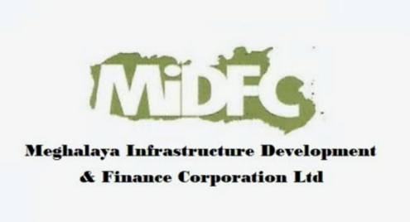

Meghalaya Infrastructure Development Finance Corporation (MIDFC) Ltd.
House No. L/A-56, Lower Nongrim Hills, Top Floor,
Meghalaya Basin Development Authority (MBDA) Building,
Shillong East Khasi Hills, Meghalaya-793003

Executive Summary-ni Saransh

1. Project-ni Background Talatani

“World Bank aro Meghalaya Government-ni dakgipa Meghalaya Logistics and Connectivity Improvement Project (MLCIP) ong·a East aro West Meghalaya-o climate-resilient dakgipa road connectivity aro logistics infrastructure-ko silrata ong·atna nangnika. Ia project-ni under-o dakgipa sub-project ong·a Songsak–Mendipathar Road (SMR), Corridor-6, jeni lambak bilsi 36 km ong·a, aro East aro North Garo Hills District-rangko re·atgipa ong·a. Ia road ong·a grong-grongni man·dimang, bazar, hospital, industry area aro administrative center-rang baksa jring-jrotgipa regional connector ong·a.”

2. Resettlement Action Plan-ni Nanganani aro Karana

“Resettlement Action Plan (RAP) rangko Songsak–Mendipathar Road-ko bilsi ong·atna aro re·atgipa kamrang dakon, existing Right of Way (RoW) ning·o ong·gipa social impact-rangko silrata aro samja·na dakgipa ong·a. Ia project Sixth Schedule area-o ong·a, jekon customary land tenure system-rangni dakgipa niyom-rang jachakgipa ong·a. A·songni affected household-rang Scheduled Tribe community-o ong·gipa ong·a, uni gimin RAP World Bank ESF (ESS5 aro ESS7), national aro state-ni niyom-rang baksa melgipa ong·a, aro indigenous man·dimangni a·kita aro janggini kamrangko rakkia-na Free, Prior, and Informed Consent (FPIC) ko dakchaka.”

3. Project-ni Impact-rang aro Affected Man·dimang

“Ia project-ni impact-rang simit ong·a aro existing 12-meter Right of Way (RoW) ning·o mangmang ong·a; additional land acquisition dakna nangja. Impact-rangni ning·o 40 Project-Affected Households (PAHs)-rangko partial ong·gipa impact dong·a, jekai temporary aro semi-pucca commercial structure, dokan, fencing aro chonchik janggini kam-rangko ong·gipa osokko dakgipa ong·a. Corridor of Impact (CoI) ning·o 100 percent census survey dakgipa ja·mano 137 Project-Affected Persons (PAPs)-rangko chagronggipa ong·a. A·songni affected man·dimang pilak Garo Scheduled Tribe community-o ong·gipa ong·a.”

4. “Socio-Economic Profile-ni Talatani

“Ia project corridor 20 grong aro 25 habitation-rangko re·atgipa ong·a, jeni man·dimang bang·a Scheduled Tribe ong·gipa aro matrilineal social structure-ko ja·rikgipa ong·a. Janggini kamrangni donga ong·a chonchik dokan-dokani kam, a·jal dakani, wage labor aro chonchik business-rang. Socio-economic survey-o vulnerable household-rangko chagronggipa ong·a, jekai me·chikni nokgipa household, ma·grik man·dimang aro below poverty line-o donggipa nokdang-rang. Literacy aro income level-rang settlement settlement-o ong·gipa ong·a, jeni gimin rural socio-economic condition-rangko mesokgipa ong·a.”

5. Consultation, Disclosure aro Free, Prior and Informed Consent (FPIC)

“Project preparation-ni somoi-o stakeholder consultation-rangko bang·en dakgipa ong·a. Project planning-ni important stage-rang-o PAPs, Nokma-rang (grongni nokgipa), GHADC official-rang aro community representative-rang baksa FPIC consultation-ni tin-ti round dakgipa ong·a. Consultation-rang local language-rangko jakkalgipa aro cultural niyom-rangko man·gipa tariko ja·rikgipa ong·a, aro project-ni impact-rang, mitigation measure-rang, eligibility aro entitlement-rangni gimin chanchigrikgipa ong·a. Community-ni feedback-rangko project design-o rongtalgipa ong·a, aro RAP disclosure implementation-ni somoi-o ja·rikangna donggipa ong·a.”

6. Eligibility aro Entitlement-ni Talatani

“Eligibility CoI (Corridor of Impact) ning·o ong·gipa titleholder-rang, non-titleholder-rang (encroacher aro squatter), aro vulnerable household-rangko man·chapa. Entitlement-rang MPWD Entitlement Matrix-ni ning·o dakgipa ong·a, jekon RFCTLARR Act, 2013 aro World Bank ESF baksa melgipa ong·a. Affected structure-rangna compensation full replacement cost-o on·gipa ong·a, aro resettlement assistance, livelihood restoration support aro Grievance Redress Mechanism (GRM)-o re·atna man·gipa dakchakani baksa man·dimangni janggini ong·senggipa gita dong·ta ba silrata ong·atna dakgipa ong·a.”

7. Institutional Arrangement-rang aro Grievance Redress

“RAP-ko Meghalaya Public Works Department (PWD) dakgipa ong·a, aro E&S Cell, district administration aro GHADC-ni dakchakani baksa kam ka·gipa ong·a. Complaint-rangko transparent aro somoi-ni ning·o chanchigrikna man·gipa gita two-tier Grievance Redress Mechanism (GRM) ko established dakgipa ong·a, jekon grong level, district level aro state level-o re·atna man·gipa ong·a.”

8. Implementation-ni Somoi Talatani aro Budget

“RAP-ko phased manner-o dakgipa ong·a, aro civil works baksa somoi melgipa gita ka·gipa ong·a. Affected section-rang-o construction kam a·bachengna skang compensation aro assistance pilak on·chonggipa ong·a.
Resettlement aro Rehabilitation (R&R) ni total budget-ko estimate dakgipa ong·a, aro u·o structure-rangni compensation, resettlement assistance, livelihood restoration, administrative cost, monitoring aro contingency-rang pilak baksa ong·a.”

9. Monitoring aro Evaluation-ni Dakgipa Kamrang

“RAP-ni ka·gipa kamrangko thik ong·e dakna internal aro external monitoring mechanism-rangko jakkalgipa ong·a. Monitoring indicator-rang physical progress, financial disbursement, grievance redress aro livelihood restoration-ni result-rangko man·chapa. Impact evaluation-o affected household-rang janggini dong·ani gita dakbaria ba silrata ong·atna man·gipa ong·ama ong·ja uko chanchigrikgipa ong·a.”

10. Grievance Solani Dakgipa Mechanism
“Ia flowchart-o two-tier grievance redressal mechanism-ko mesokgipa ong·a, jekon complaint-rangko chanchigrikna jachakgipa responsibility-rang aro resolution-na somoi-rangko talatgipa ong·a.”
Tier I: Project Site Level | Responsibility: VECs & Headman  Timeline: Resolution within 15 days  If unresolved → Escalate to PMU (Tier II)
Tier II: State Level (PMU) | Responsibility: Secretary Planning, Chief Engineer,  Project Director, Social Expert  Timeline: Resolution within 15 days

Grievance Solani Dakgipa Mechanism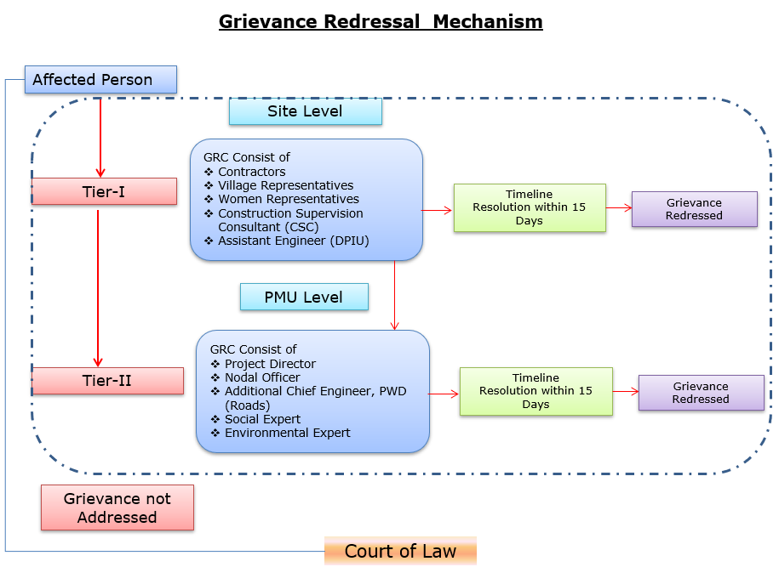

Grievance-rangni Contact-ni Talatani
Description | Contact details
Company: | PWD, Meghalaya
To: | Chief Engineer-cum-Nodal officer
Address: | HV9P+GFJ, Lachumiere, Shillong, Meghalaya 793001
E-mail: | esmlcip@gmail.com
Website: | http://megpwd.gov.in/contacts.html
Telephone: | Tel: 0364-3572466
Fax: | -

11. Bon·chotani
“Songsak–Mendipathar Road (SMR) Road-ni RAP project-ni inclusive development-ko dakchakani, tribal man·dimangni a·kita-ko rakkiani aro social sustainability-ko mesokgipa ong·a. Resettlement impact chonchik ong·ani, community baksa namgipa engagement aro thik ong·gipa mitigation measure-rangni gimin, ia project-o socio-economic benefit bang·en ong·gipa ong·na chanchigipa ong·a, aro affected man·dimangko saman aro nyay ong·e chanchigrikgipa ong·na dakchakgipa ong·a.”

